# Project Report

|  |  |
| --- | --- |
| **Product Name** | Advanced Certificate in Web Development |
| **Qualification Name (ITSF)** | NICF-Advanced Certificate in Infocomm Technology (Software & Applications) |
| **Product Name** | NICF-UI Frameworks |
| **Module Name (ITSF)** | NICF-UI Frameworks |

|  |  |  |  |
| --- | --- | --- | --- |
| **Student name** | | **Assessor name** | |
| Agung Yuda Pratama | |  | |
| **Date issued** | **Completion date** | | **Submitted on** |
|  | 21-12-2022 | | 21-12-2022 |
|  | | | |
| **Project title** | **Design & Develop Front End Community Portal RIA application.** | | |

|  |
| --- |
| **Learner declaration** |
| I certify that the work submitted for this assignment is my own and research sources are fully acknowledged.  Student signature: Date: 21-12-2022 |

**Content**

1. Project background
2. Project Objectives
3. Business Process & Solution Architecture
4. Task 1
5. Task 2
6. Task 3
7. Task 4
8. Task 5
9. Task 6
10. Task 7
11. Task 8
12. Task 9
13. Task 10
14. **Project Background**

The Writer has been approached by "ABC Jobs Pte Ltd" to work on creating a community platform for software developers as a website developer. Through Module 3, Module 4, Module 5, and the Capstone Project, the project will be continued. Design, Development, and Implementation of Front End RIA Applications are the focus of this module. The project's goal is to create a community portal that is comparable to LinkedIn.com. The Registration Page will be used by users to register in the portal. Users of the site have access to a variety of search options, including First Name, Last Name, Company Name, City, and Country. After searching for users, users' Public Profiles will be available for viewing. Users can sign in using the portal., request forgotten passwords and Update their profile information. The scope of the project in this module is for the development of Ga UI front end using HTML, Javascript, CSS & Angular.

1. **Project Objective**

This Project is used for the Summative Assessment of students in the Module ‘UI  
Frameworks of the ITSF Course ‘Advanced Certificate in Web Development”

* To gather data, analyze what you see, and then create a user experience measurement to create a community portal prototype
* To perform a usability test, get feedback, and then develop suggestions
* Add it to the prototype.
* A documentation effort is to be made
* Making a project presentation

Tools & platforms used

1. Laptop Acer Aspire 5
2. Windows 10 2H22
3. Axure
4. Google Chrome
5. Microsoft Edge
6. Linkedin.com
7. Glints.com
8. Jobstreet.co.id
9. Microsoft Word
10. Microsoft PowerPoint
11. **Business Process & Solution Architecture**

The business process architecture flow can be shown below.

* Software developers could do a variety of tasks after logging in. They must first register if they still require an account.
* After logging in, users can see their profile and make changes to it, look up other users and see their profile, send and reply to messages, see, post, and participate in discussion threads for other job openings, and finally sign out.
* The administrator can view, change, and control user data and their profile. Additionally, invite candidates to become members of ABC Jobs.

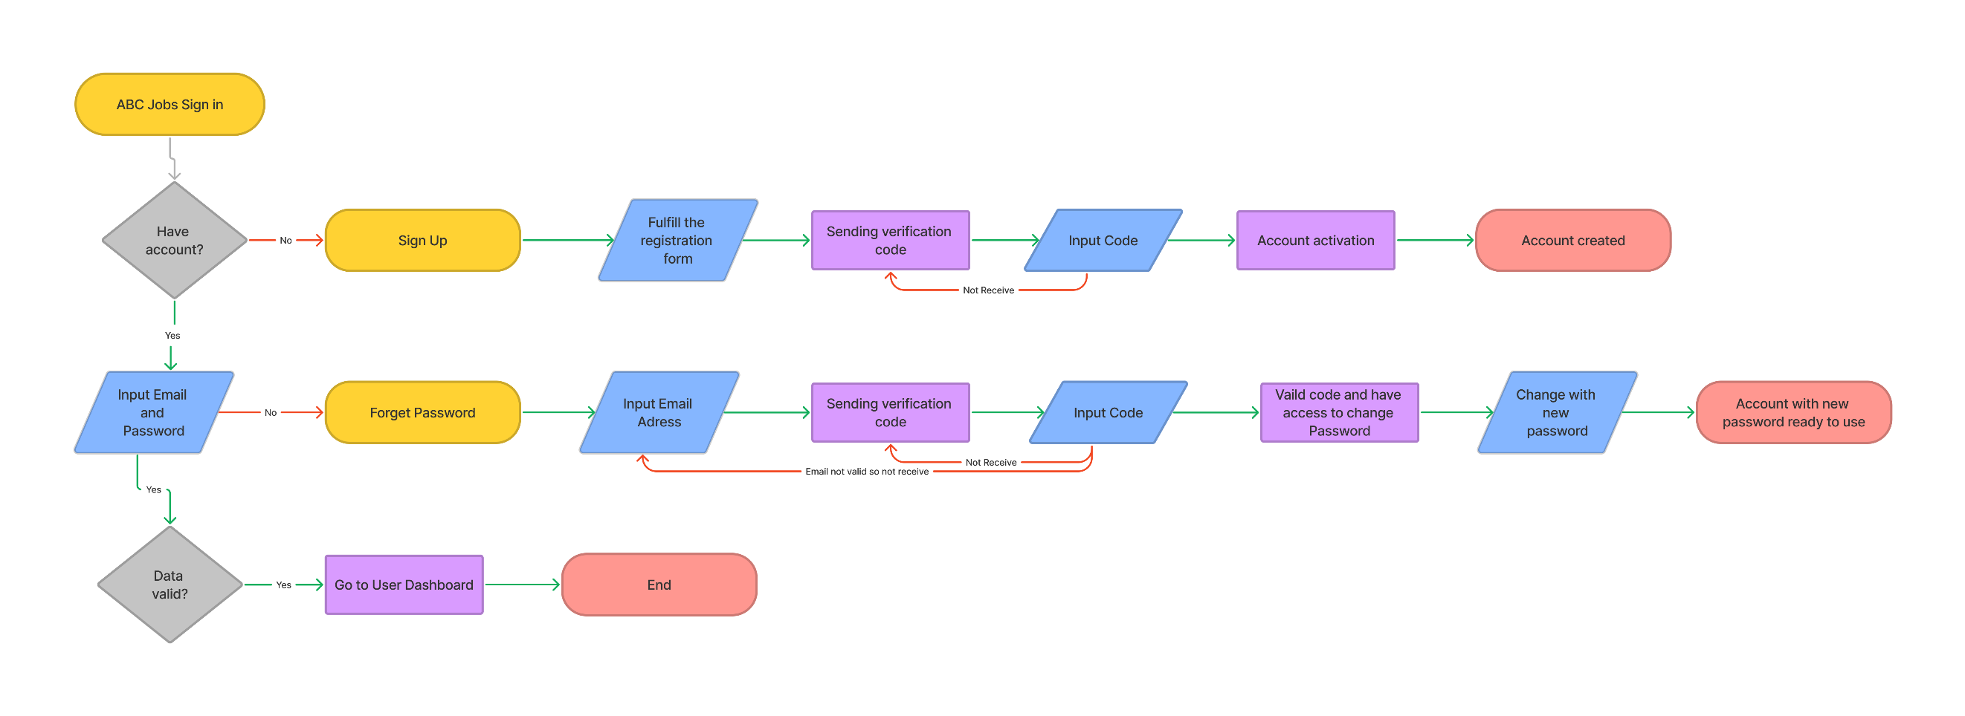

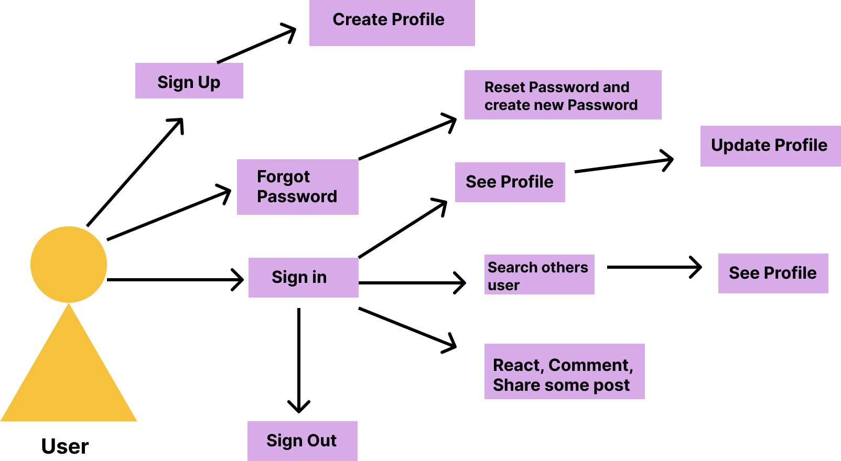

1. **Task 1**

Task Statement:

1. Briefly explain techniques and methods for gathering and analysing user feedback.

2. Find at least 2 websites which are similar to community portal and visit and use them

and record your experiences.

Solution:

Task 1.1

The Writer Used a survey method to gather user needs, user difficulties and feedback about the community portal that has been made. Ask about what the user needs, what user difficulties are when using the community portal, how long it takes to fill out the form of registration, whether the UI is good or not, is less content or too much content, note user quotes, listen to their goals, note actions they take. The Writers ask directly to the user.

Task 1.2

Linkedin.com

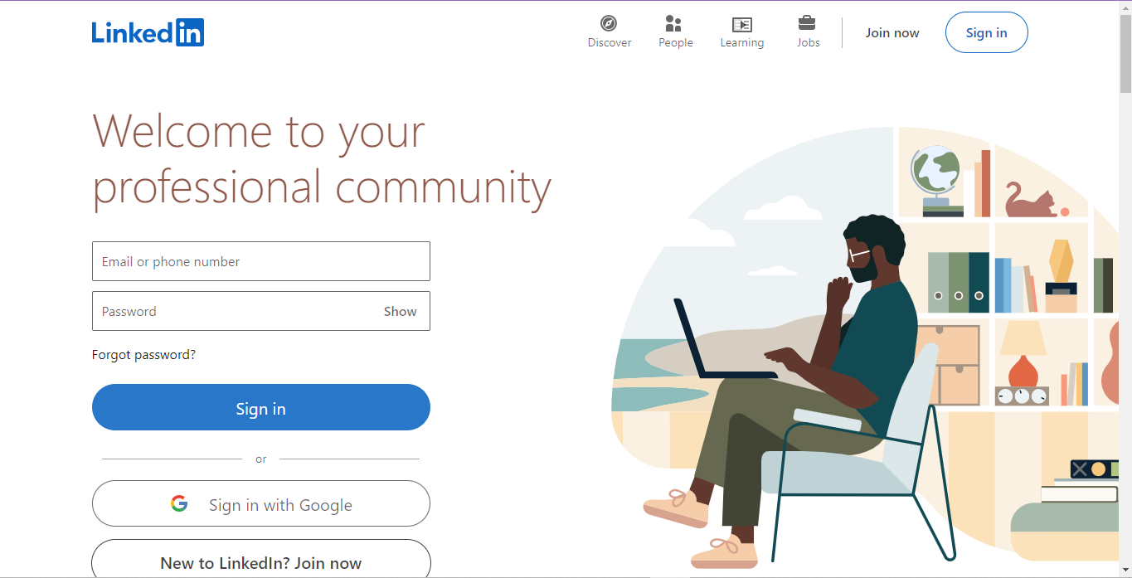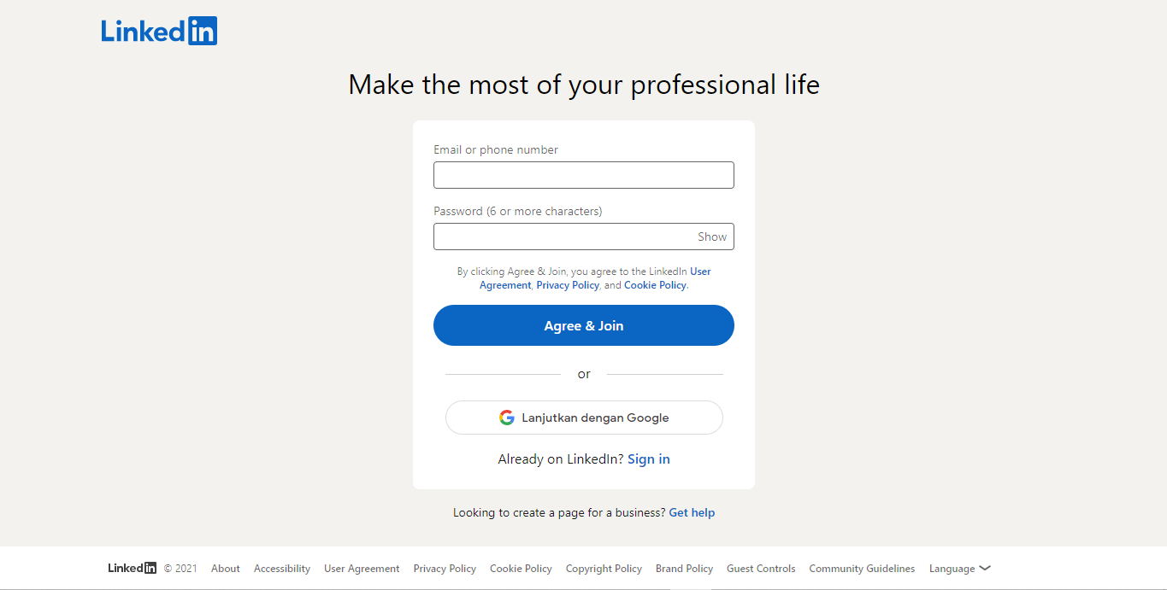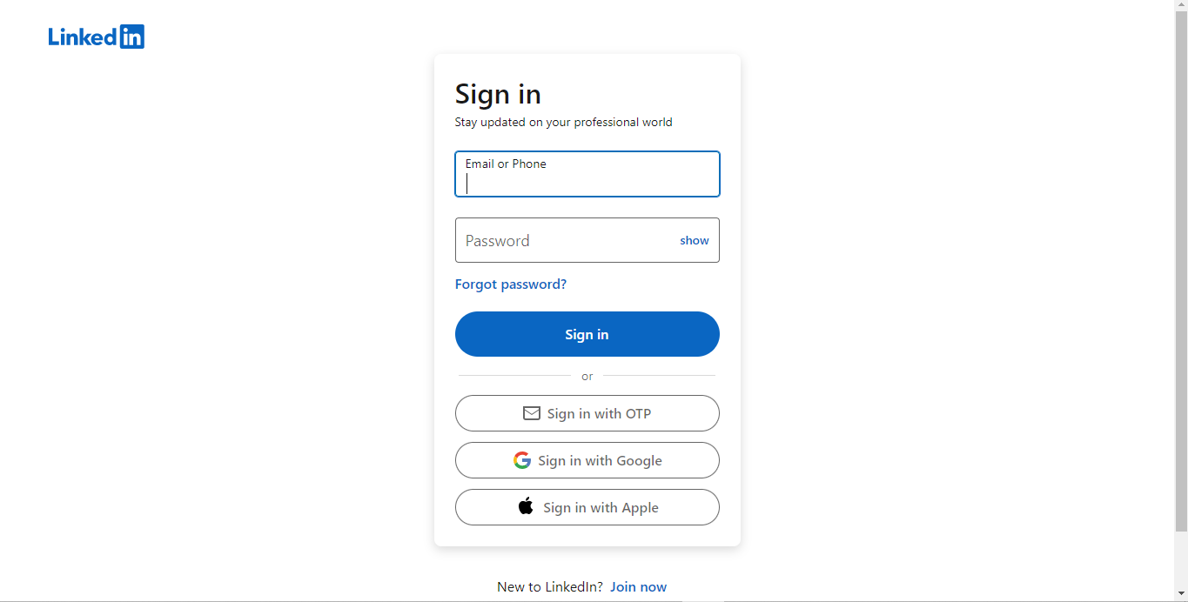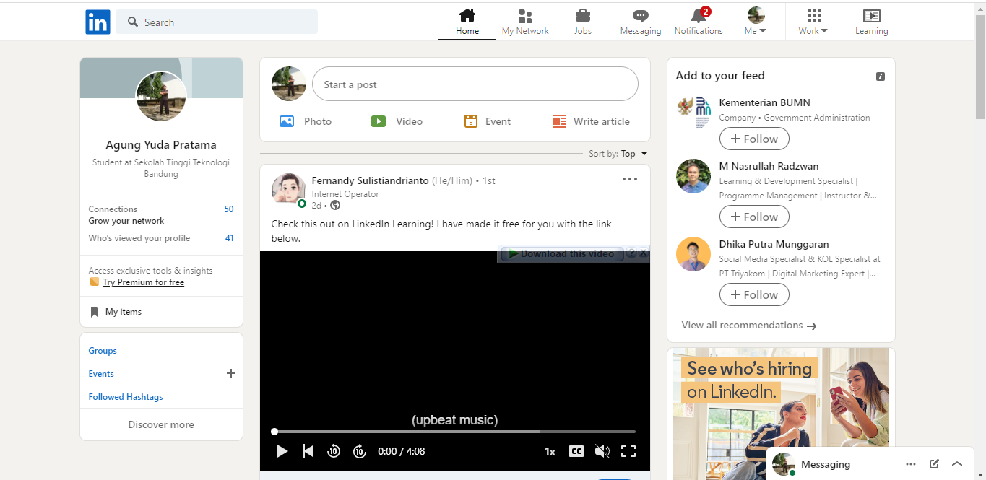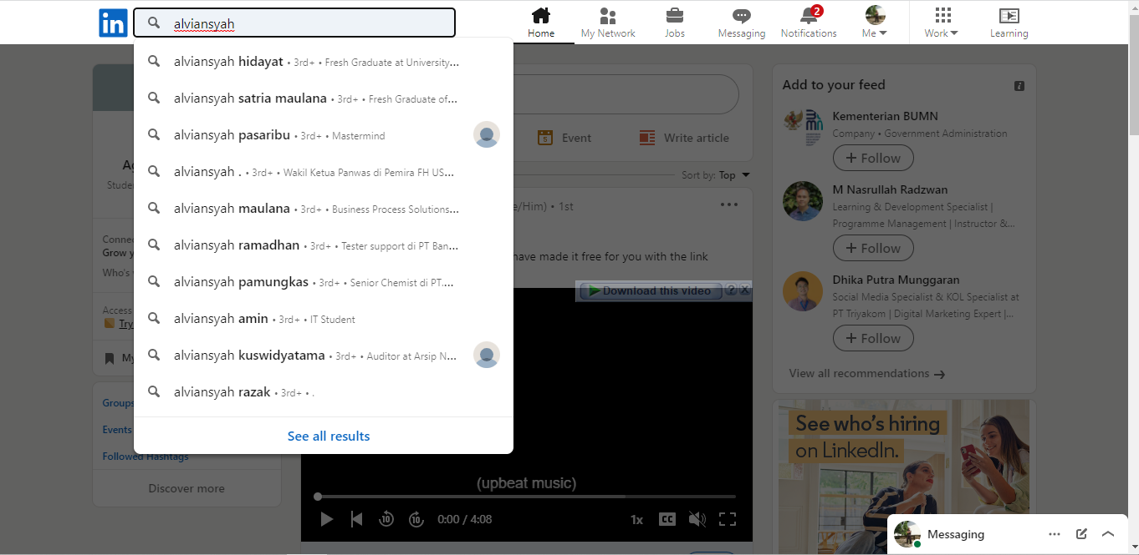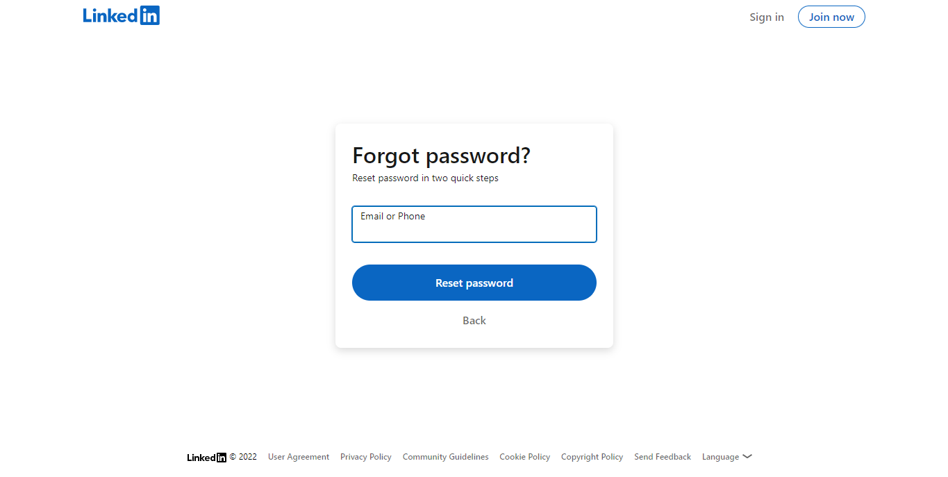

LinkedIn is the world's largest professional network on the internet. You can use LinkedIn to find the right job or internship, connect and strengthen professional relationships, and learn the skills you need to succeed in your career. You can access LinkedIn from a desktop, LinkedIn mobile app, mobile web experience, or the LinkedIn Lite Android mobile app.

LinkedIn is also a resource for professionals to find jobs, research companies, and get news about their industry and business connections.

Glints.com

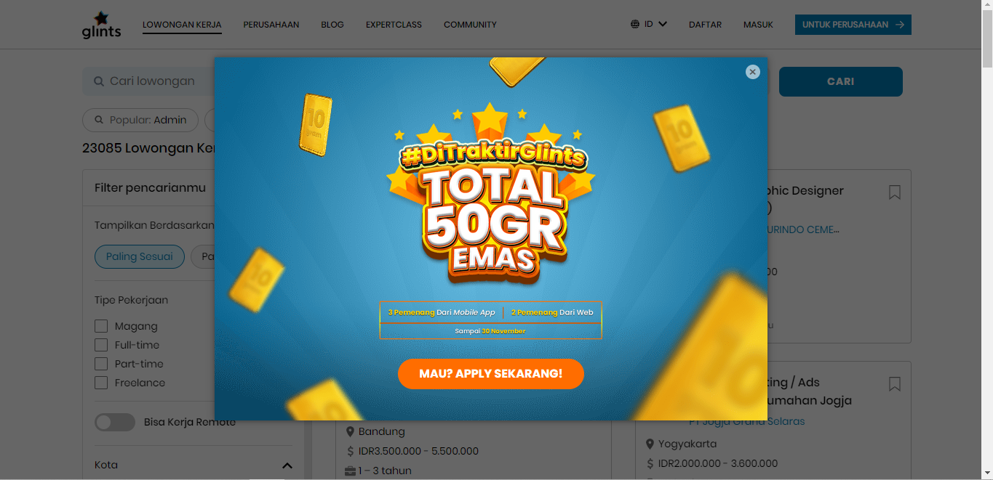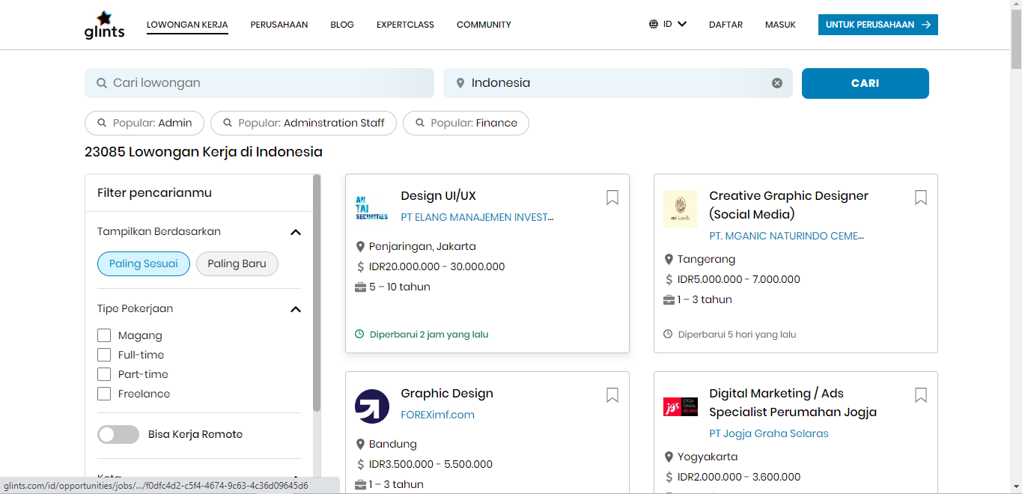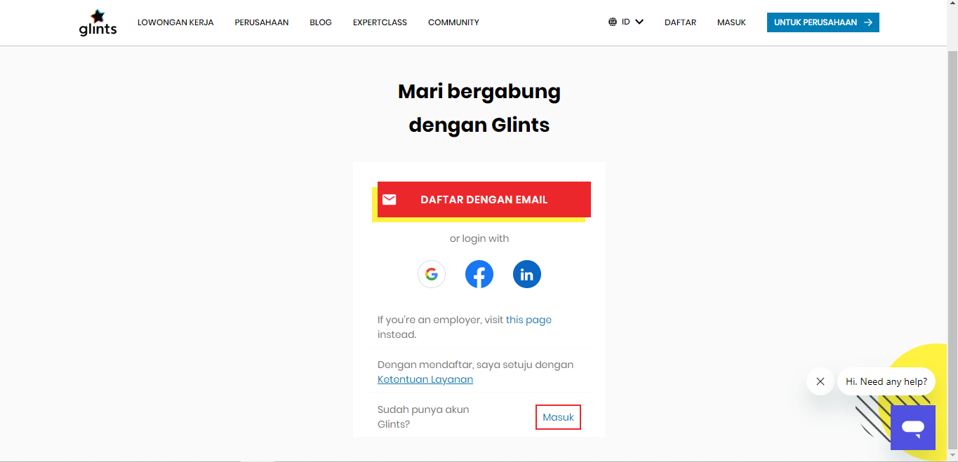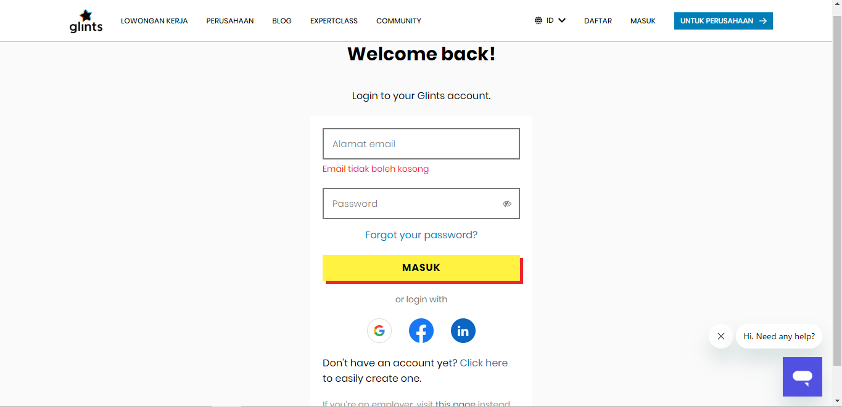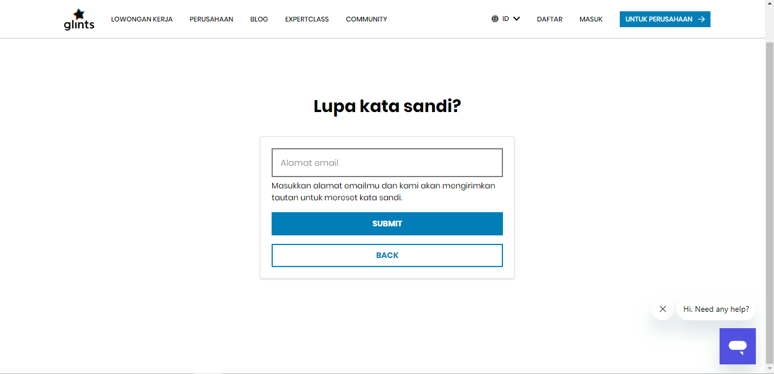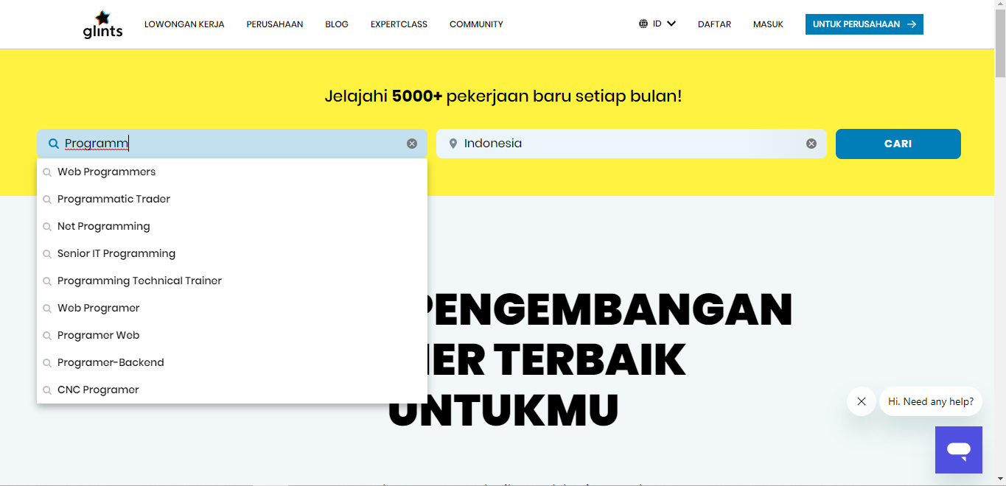

Glints is an online job recruitment platform headquartered in Singapore. The company was founded in August 2013 by Oswald Yeo, Looi Qin En and Seah Ying Cong. Through the website, users can apply for internships and full-time, part-time or project-based positions with partnered companies.

Glints is a career discovery platform that bridges the gap between education and employment by being a professional platform for young people focused on career discovery and development. We work with universities and polytechnics to reach graduates and match them with quality employers.

## Task 2

Task Statement:

1. Discuss, study and analyse the user experience based on the observations done in Task 1.

2. Study the experience for 2 to 3 scenarios

Solution:

First, The Writer visits Linkedin because Linkedin is the world's largest professional network on the internet. The writer's first impression is really good about this website because it looks clean and fresh and has a solid layout. Easy to navigate when we land on this website. The top right is a button to register and log in to the website. Users can also log in without clicking the button on the top right. Users can also login into the home page when they land on Linkedin.

According to The Writer's experience, there are quite a few procedures before receiving the confirmation email. Although we can subsequently alter our profiles, the information we must supply cannot be skipped. In the same way that there are many potential scenarios for a bio or work history, the most frequent one is when a recent graduate lacks the necessary experience but cannot claim to be a student because they have already graduated. Finally, the feed page appears (home). Numerous features are provided to us, including suggestions for employment opportunities, contacts, and other items in which you might be interested. The following are feeds of previous posts, and there is space for us to write our own. There is a search column as well. The menus are easily accessible, and we can access our connections, jobs, user profiles, settings for managing content message notifications, and other menus.

The second website that The Writer found similar to Linkedin is Glints. The function and purpose of this website are the same. Is it to find a professional network and job on the internet with a trusted company. The color design of this website is quite similar to Linkedin, using white, yellow, blue, and black for the footer. When we land on this website, they will offer Glints Expert Class. On this website, we can directly choose a location to make it easier when searching for jobs under the nearest location. On the homepage before login, there is more content compared to Linkedin. On the navbar, there is more button to go to what the user needs. Also, there is a column for search a job. The navigation is simple. We can go to our associations, jobs, and user profile by setting and managing content message notifications and other menus we can access.

**The first scenario, New User**

In LinkedIn, as described before, we must complete the required Information. We need to be less flexible until the confirmation email as we are still in registration, and we can update our profile later. The Writer proceeded with it and chose the 'Student' option as The Writer still needed to gain job experience. The Writer needed clarification when typing where The Writer studied because it did not directly show my university there. It took me about 1 minute to finish the problem. After we finish Inputting all the Information, they will send us the email confirmation, and we must enter the OTP they give to confirm. While The Writer did not experience any Input errors, he could proceed with no problem. However, it was still a long process of registration, approximately 15 minutes.

Glints, also the same as LinkedIn, need to provide the flexibility to fill in the Information. We can sign up with another provider, but The Writer chooses to create manually. The Writer entered his name, phone number, location, email, and password. There is no show-hidden password, so it made me re-type again to ensure The Writer put the password correctly. Fortunately, Glints provided the Indonesian language. So it is easier to use this website. Even with the inexperienced, it will be easy because there is the Indonesian language.

Second Scenario, Find another user or job

Because it is located in the menu navigation area, we can immediately see the search column on LinkedIn's homepage and try to write the person's name or another phrase we are looking for. When you type, there are many suggestions displayed. We are taken to the results page after pressing enter. There, we can exclude certain types or additional keywords.

Similar to LinkedIn, Glints has a search function on its homepage. Of course, The Writer also attempts to type a random person's name there. Although they displayed a suggestion filter rather than a suggestion result, The Writer pushed enter straight to the results page. After that, it shows many people many job orders, and we can use the filter to make the output more correct.

## Task 3

Task Statement:

1. Identify the performance levels and gaps between user experience in the study & desired

user experience.

2. Measure the level of user engagement & stickiness with the product.

Solution:

The Metrics used in this project report is based on 3 scenarios, Login, Registration and Forget Password. Here the result:

LinkedIn

|  |  |  |  |
| --- | --- | --- | --- |
| Scenario | Expected Time to Complete in secs | Actual Time to Complete in secs | Performance Gap in secs |
| **Registration** | 20 | 20 | 0 |
| **Login** | 15 | 10 | 5 |
| **Forget Password** | 40 | 55 | 15 |

Glints

|  |  |  |  |
| --- | --- | --- | --- |
| Scenario | Expected Time to Complete in secs | Actual Time to Complete in secs | Performance Gap in secs |
| **Registration** | 30 | 30 | 0 |
| **Login** | 15 | 10 | 5 |
| **Forget Password** | 40 | 55 | 15 |

The performance on the LinkedIn website turned out to be as expected as a whole. In the login, it is quicker than expected. However, while waiting for verification to forget the password, there is a time lag when the server sends the verification code via email.

Also same expectation on the Glints website. There are no big issues when users come to a website and do the 3 scenarios. But, in the forgot password also has a delay time for waiting code verification.

These two websites are easy to use and have no big issues.

## Task 4

Task Statement:

1. Develop & document 3 metrics to measure the user experience.

Solution:

1. Task Success Rate

❑ The task success rate (TSR) measures the number of correctly

executed tasks.

❑ Used very frequently.

❑ You can measure the TSR by a clearly defined endpoint – for example, filling out a form or buying a product.

❑ Before collecting data, be clear about what goals you consider a success in a particular case.

1. Time on Task

❑ Test the user's ability to finish the task.

❑ The final grade is displayed as a percentage of successful participants relative to all participants.

1. Customer Satisfaction

❑ The CSAT is another attitudinal UX KPI that expresses customer

satisfaction in a convenient metric.

❑ Users/testers are asked: How satisfied are you with (website,

product, service, etc.)?

❑ The result is a percentage from 0 to 100, where 100 stands for

maximum customer satisfaction.

## Task 5

Task Statement:

1. Create the steps in User Interaction process for various scenario.

2. Create a flow chart for user interaction.

Solution:

|  |  |
| --- | --- |
| Flowchart | Steps |
|  | 1. User goes to the Sign in Page. 2. User must enter the email and the password that has been made. 3. The system will check the data after the user clicks a sign-in button if valid user will continue. If false or different user will re-enter the email and password again. 4. Next, Thank you page will show ,and there is a button to continue to User Dashboard. |
|  | 1. User at the sign-up page.  2. User enters their name, phone number, email, and password, confirms the password, and clicks sign up.  3. If entries are invalid, the user will see an error state above the button.  4. If valid, a verification code will be sent on the next page.  5. If the user did not get the code, the user might click the resend button.  6. User inputs the verification code.  7. When clicking Create Your Account, the user will direct to create a profile  8. The page will direct to the login page. |
|  | 1. User at the sign-in page and click the forgot password  2. User enters the email that is used for sign in  3. A code will be sent to the user's email  4. If the user did not get the email, the user might click the resend button  5. User opens their email and, copies the code verification, pastes in the email verification page.  6. User enters a new password and confirms the password  7. When success directed to sign in page |
|  | 1. In navbar, we click the search field 2. Enter the name of the person or company 3. System will find the closest result 4. The If user press enter, it will display all of the result |
|  | 1. Go to the user profile 2. Click edit profile 3. We can change the first name, last name, current position, country, and city. 4. After we complete edit the profile, we can click save 5. System will collect and update the data |

## Task 6

Task Statement:

1. In the Websites study’s get the general user response from one other user.

Solution:

From Reihan on LinkedIn and Glints:

“LinkedIn is the biggest platform in the world that he gave his by a professional HRD company and others. The function of LinkedIn is similar to Facebook, like Twitter but in the professional context. The Linkedin website has UI, which will make the user use this website more effortlessly, and on LinkedIn, you can make a connection with professional people who one expert in their skills. We can pass the Login form, Sign up form and forget password in less time.”

“Before my friend told me about Glints, I didn’t really know what Glints it is or what their function of Glints. Well, when I saw this website, my first impression was good UI. I like it because is default using the Indonesian language so it is easier for the user from Indonesia to access, register and login in to this website. Same with LinkedIn there are no big issues when I try to register, login and do some search in search bar. But LinkedIn is Better in my opinion”

## Task 7

Task Statement:

1. Create a Prototype for the proposed system, with at least 5 screens

2. Get the user response and classify them to various types.

Solution:

|  |  |  |
| --- | --- | --- |
| No. | Widget | Interaction |
| 1 | Home Page  1detail | |  |  |  | | --- | --- | --- | | **No.** | **Widget** | **Interaction** | | **1** | Logo Company | To the home page | | **2** | Sign In | To the sign-in page | | **3** | Join now | To the registration page | | **4** | Get Started | To the sign-in page | |
| 2 | Registration Page | |  |  |  | | --- | --- | --- | | **No.** | **Widget** | **Interaction** | | **1** | Logo Company | To the home page | | **2** | Agree & Join | Agree to create an account | |
| 3 | Confirmation Page | |  |  |  | | --- | --- | --- | | **No.** | **Widget** | **Interaction** | | **1** | Confirm and Continue | To proceed with the creating account and will show the code for verification | |
| 4 | Confirmation Email Page | |  |  |  | | --- | --- | --- | | **No.** | **Widget** | **Interaction** | | **1** | Create Your Account | To proceed creating account | |
| 5 | Login Page | |  |  |  | | --- | --- | --- | | **No.** | **Widget** | **Interaction** | | **1** | Logo Company | To the home page | | **2** | Sign-in | For sign-in user account | |
| 6 | Thank You Login Page | |  |  |  | | --- | --- | --- | | **No.** | **Widget** | **Interaction** | | **1** | Continue | To proceed into User Dashboard | |
| 7 | Forgot Password Page | |  |  |  | | --- | --- | --- | | **No.** | **Widget** | **Interaction** | | **1** | Logo Company | To the home page | | **2** | Submit | To store the email for getting code verification | | **3** | Back | Back to Login Page | |
| 8 | Email Verification Page | |  |  |  | | --- | --- | --- | | **No.** | **Widget** | **Interaction** | | **1** | Submit | To proceed with code verification for getting access to change password. | |
| 9 | Change Password Page | |  |  |  | | --- | --- | --- | | **No.** | **Widget** | **Interaction** | | **1** | Change Password | To change the old password with the new password | |
| 10 | Dashboard Page | |  |  |  | | --- | --- | --- | | **No.** | **Widget** | **Interaction** | | **1** | Home | To the user dashboard | | **2** | My Profile | To the user profile | | **3** | Log Out | To log out the account | | **4** | View My Profile | To the user profile | |
| 11 | My Profile Page | |  |  |  | | --- | --- | --- | | **No.** | **Widget** | **Interaction** | | **1** | Home | To the user dashboard | | **2** | My Profile | To the user profile | | **3** | Log Out | To log out the account | | **4** | Edit Profille | To access menu editing profile | |
| 12 | Edit Profile Page | |  |  |  | | --- | --- | --- | | **No.** | **Widget** | **Interaction** | | **1** | Close button | To close the editing profile | | **2** | Save | To save the profile after editing. | |
| 13 | List Search Result Page | |  |  |  | | --- | --- | --- | | **No.** | **Widget** | **Interaction** | | **1** | Home | To the user dashboard | | **2** | My Profile | To the user profile | | **3** | Log Out | To log out the account | | **4** | See Profile (Edward Steingerd) | To see the profie | |
| 14 | Public Profile Page | |  |  |  | | --- | --- | --- | | **No.** | **Widget** | **Interaction** | | **1** | Home | To the user dashboard | | **2** | My Profile | To the user profile | | **3** | Log Out | To log out the account | |
| 15 | Company Search Result Page | |  |  |  | | --- | --- | --- | | **No.** | **Widget** | **Interaction** | | **1** | Home | To the user dashboard | | **2** | My Profile | To the user profile | | **3** | Log Out | To log out the account | |

## Task 8

Task Statement:

1. Demonstrate and let the users give feedback on prototype and document them

2. Make suggestions to improve the user experience and implement them in the prototype

Solution:

User Feedback

The registration process was quite easy and informed me of the data I needed to enter. It was simple to log in. Instructions for password reset were obvious. Updated profile actually works, and the updated information is visible. If the proper inputs are entered first, no users will appear until the search function is activated, and the search input can be further improved using filters. Good work all around.

According to user feedback, the prototype's consistency and simplicity in design are good indicators of usability because the user was able to use the functionalities quickly and effectively. Including a predictive search engine in the search function would make looking for other users simpler.

## Task 9

Task Statement:

1. Create 3 Usability tests and execute the usability tests with a user

2. Get the users to use the modified prototype

3. Gather feedback and measure its technical viability and effectiveness

Solution:

Participants:

1. Anjar Wibawa (18), Digital Bussiness Student
2. Abdul Rahman (19), Software Engineering Student
3. Syukur (18), Software Engineering Student

Methods:

The Writer gives them the laptop and let them to do the scenario.

First Usability Test

Registration new account.

|  |  |  |  |  |
| --- | --- | --- | --- | --- |
| **No.** | **User** | **TOT** | **TSR** | CSAT |
| **1** | Anjar Wibawa | 60 seconds | Success | Satisfied |
| **2** | Abdul Rahman | 78 seconds | Success | Satisfied |
| **3** | Syukur | 46 seconds | Success | Very Satisfied |
| **Result** | | 61 seconds | 100% | 100% |

Observation & Analysis

* Overall, they can do with no issues except Anjar. When he tries to do registration, he always asks me step by step, but he can make it faster than Rahman.
* They can navigate the community portal easier.

Second Usability Test

Login with new account.

|  |  |  |  |  |
| --- | --- | --- | --- | --- |
| **No.** | **User** | **TOT** | **TSR** | CSAT |
| **1** | Anjar Wibawa | 20 seconds | Success | Very Satisfied |
| **2** | Abdul Rahman | 27 seconds | Success | Satisfied |
| **3** | Syukur | 15 seconds | Success | Very Satisfied |
| **Result** | | 21 seconds | 100% | 100% |

Observation & Analysis

* Overall, they can do with no issues. All participants are familiar with the login form.
* Time on task faster than register because just a simple form.

Third Usability Test

Forgot password account.

|  |  |  |  |  |
| --- | --- | --- | --- | --- |
| **No.** | **User** | **TOT** | **TSR** | CSAT |
| **1** | Anjar Wibawa | 28 seconds | Success | Satisfied |
| **2** | Abdul Rahman | 30 seconds | Success | Very Satisfied |
| **3** | Syukur | 21 seconds | Success | Very Satisfied |
| **Result** | | 26 seconds | 100% | 100% |

Observation & Analysis

* On average, there are no problems. They can pass this Three Usability Test
* Abdul Rahman always be on the long time in Three Usability Test.
* Syukur the fastest person in this test.